[](https://ok.ru/dk?cmd=PopLayerPhoto&st.layer.cmd=PopLayerPhotoOuter&st.layer.type=GROUP&st.layer.revNav=off&st.layer.limitedUi=false&st.layer.sphotoIds=859164993603;859164993347;859164993091;859164992835;859164992579;859164992323;859164992067&st.layer.showNav=on&st.layer.photoAlbumId=53734498041923&st.layer.epm=off&st.layer.photoId=859164993603&st.layer.opl=off&st.layer.navStartPhotoId=859164993603&st.layer.sbd=off&st.cmd=altGroupForum&st.groupId=53734489129027&st._aid=GroupTopicLayer_openPhotoLayer)

[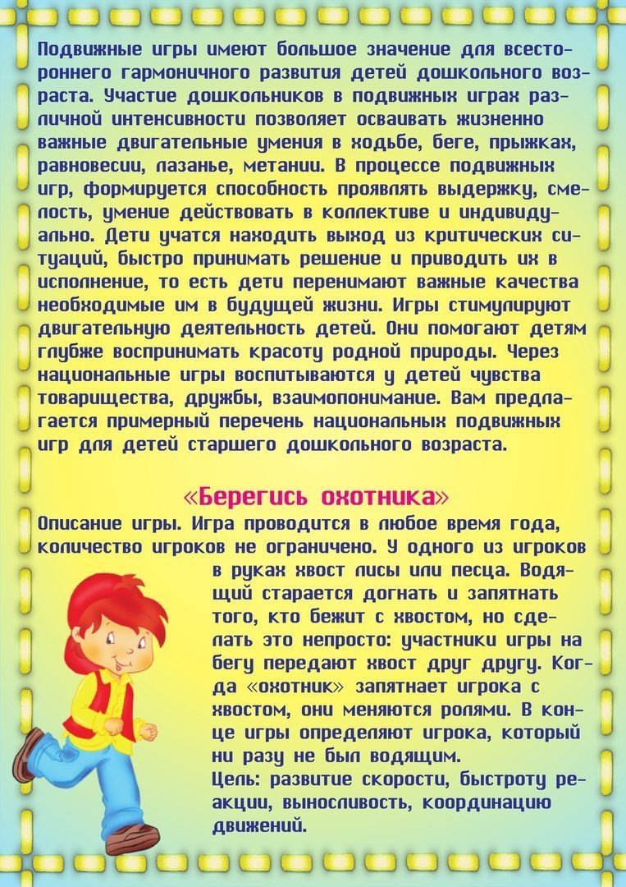](https://ok.ru/dk?cmd=PopLayerPhoto&st.layer.cmd=PopLayerPhotoOuter&st.layer.type=GROUP&st.layer.revNav=off&st.layer.limitedUi=false&st.layer.sphotoIds=859164993603;859164993347;859164993091;859164992835;859164992579;859164992323;859164992067&st.layer.showNav=on&st.layer.photoAlbumId=53734498041923&st.layer.epm=off&st.layer.photoId=859164993347&st.layer.opl=off&st.layer.navStartPhotoId=859164993347&st.layer.sbd=off&st.cmd=altGroupForum&st.groupId=53734489129027&st._aid=GroupTopicLayer_openPhotoLayer)

[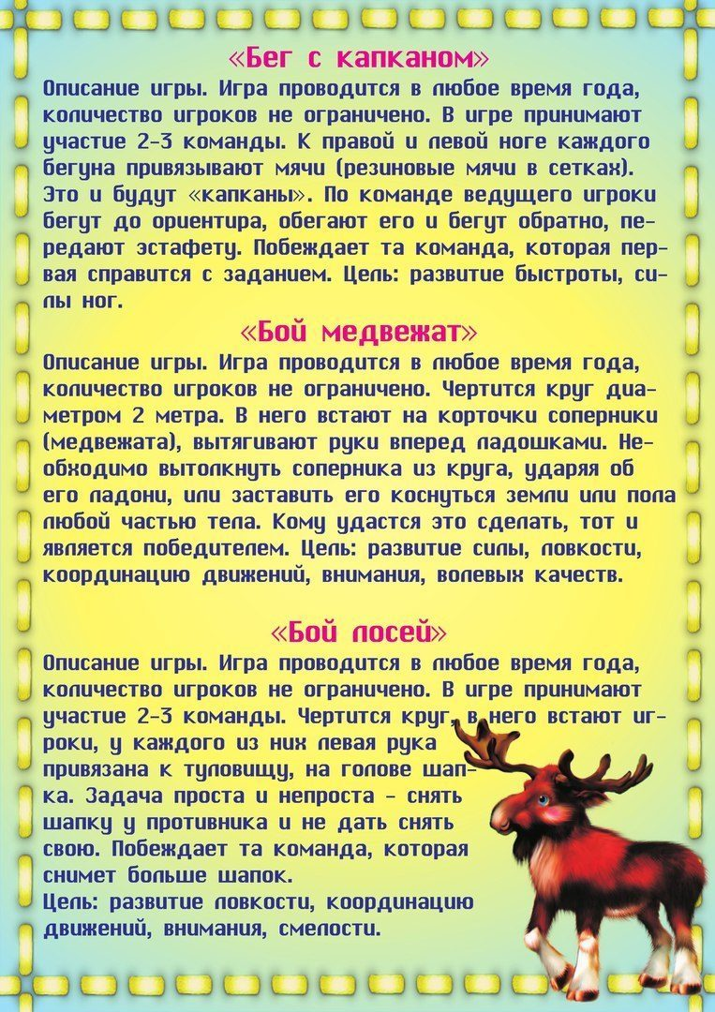](https://ok.ru/dk?cmd=PopLayerPhoto&st.layer.cmd=PopLayerPhotoOuter&st.layer.type=GROUP&st.layer.revNav=off&st.layer.limitedUi=false&st.layer.sphotoIds=859164993603;859164993347;859164993091;859164992835;859164992579;859164992323;859164992067&st.layer.showNav=on&st.layer.photoAlbumId=53734498041923&st.layer.epm=off&st.layer.photoId=859164993091&st.layer.opl=off&st.layer.navStartPhotoId=859164993091&st.layer.sbd=off&st.cmd=altGroupForum&st.groupId=53734489129027&st._aid=GroupTopicLayer_openPhotoLayer)

[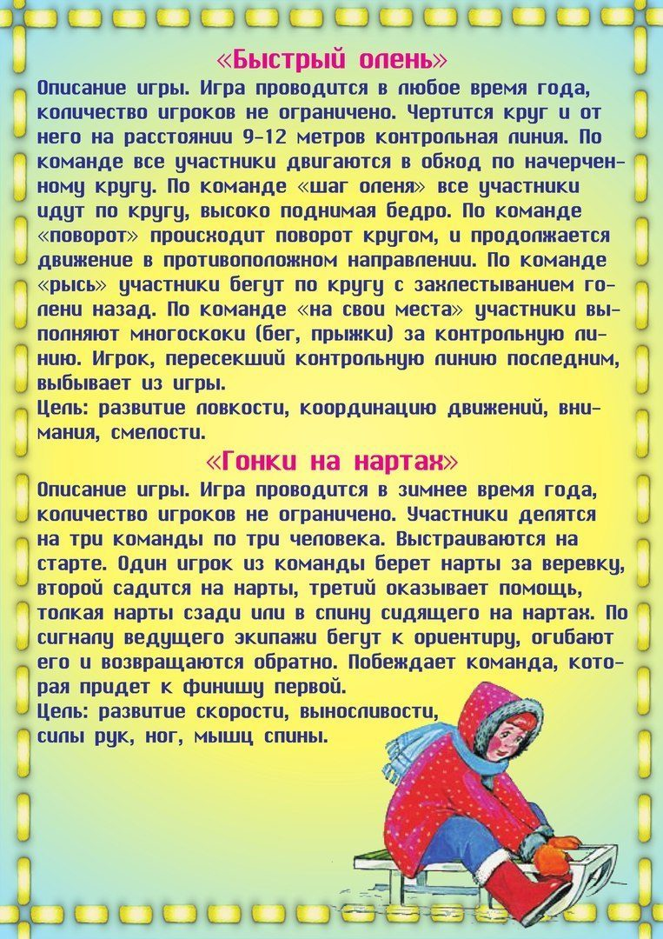](https://ok.ru/dk?cmd=PopLayerPhoto&st.layer.cmd=PopLayerPhotoOuter&st.layer.type=GROUP&st.layer.revNav=off&st.layer.limitedUi=false&st.layer.sphotoIds=859164993603;859164993347;859164993091;859164992835;859164992579;859164992323;859164992067&st.layer.showNav=on&st.layer.photoAlbumId=53734498041923&st.layer.epm=off&st.layer.photoId=859164992835&st.layer.opl=off&st.layer.navStartPhotoId=859164992835&st.layer.sbd=off&st.cmd=altGroupForum&st.groupId=53734489129027&st._aid=GroupTopicLayer_openPhotoLayer)

[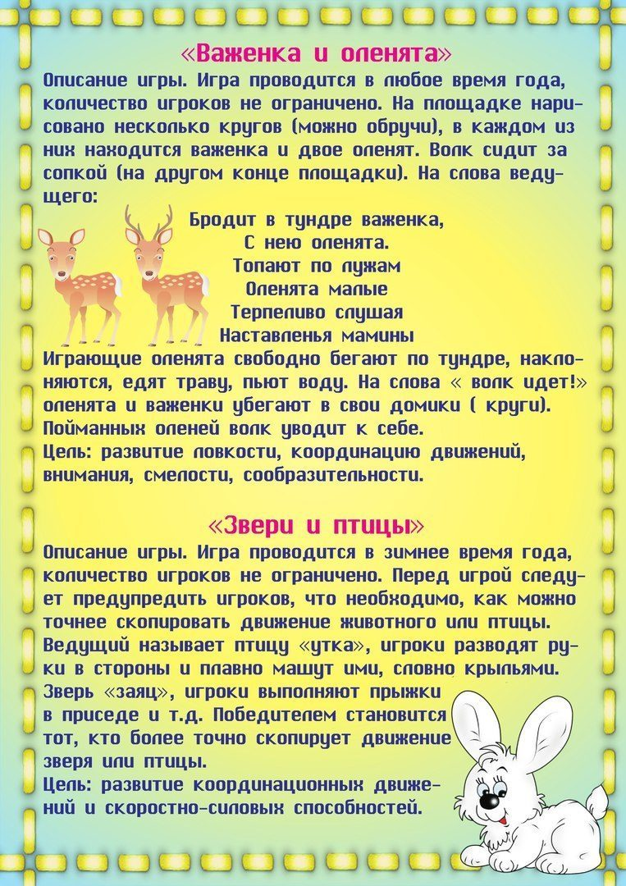](https://ok.ru/dk?cmd=PopLayerPhoto&st.layer.cmd=PopLayerPhotoOuter&st.layer.type=GROUP&st.layer.revNav=off&st.layer.limitedUi=false&st.layer.sphotoIds=859164993603;859164993347;859164993091;859164992835;859164992579;859164992323;859164992067&st.layer.showNav=on&st.layer.photoAlbumId=53734498041923&st.layer.epm=off&st.layer.photoId=859164992579&st.layer.opl=off&st.layer.navStartPhotoId=859164992579&st.layer.sbd=off&st.cmd=altGroupForum&st.groupId=53734489129027&st._aid=GroupTopicLayer_openPhotoLayer)

[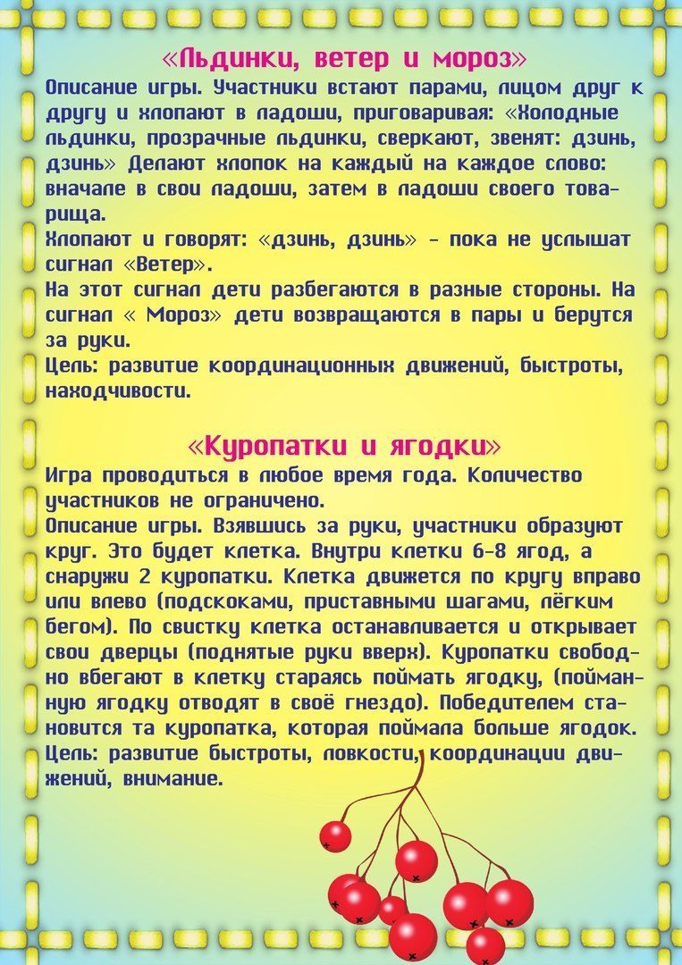](https://ok.ru/dk?cmd=PopLayerPhoto&st.layer.cmd=PopLayerPhotoOuter&st.layer.type=GROUP&st.layer.revNav=off&st.layer.limitedUi=false&st.layer.sphotoIds=859164993603;859164993347;859164993091;859164992835;859164992579;859164992323;859164992067&st.layer.showNav=on&st.layer.photoAlbumId=53734498041923&st.layer.epm=off&st.layer.photoId=859164992323&st.layer.opl=off&st.layer.navStartPhotoId=859164992323&st.layer.sbd=off&st.cmd=altGroupForum&st.groupId=53734489129027&st._aid=GroupTopicLayer_openPhotoLayer)

[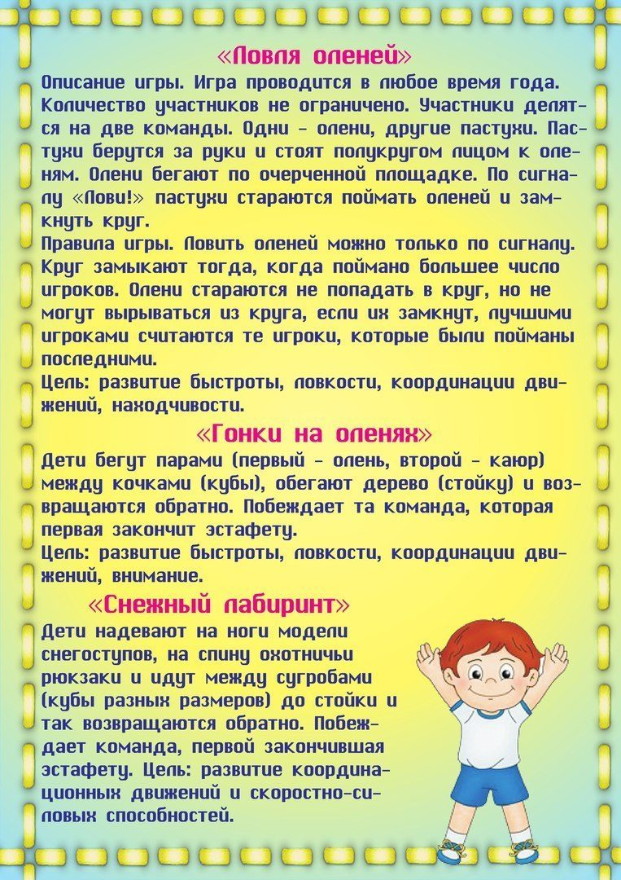](https://ok.ru/dk?cmd=PopLayerPhoto&st.layer.cmd=PopLayerPhotoOuter&st.layer.type=GROUP&st.layer.revNav=off&st.layer.limitedUi=false&st.layer.sphotoIds=859164993603;859164993347;859164993091;859164992835;859164992579;859164992323;859164992067&st.layer.showNav=on&st.layer.photoAlbumId=53734498041923&st.layer.epm=off&st.layer.photoId=859164992067&st.layer.opl=off&st.layer.navStartPhotoId=859164992067&st.layer.sbd=off&st.cmd=altGroupForum&st.groupId=53734489129027&st._aid=GroupTopicLayer_openPhotoLayer)