[](https://ok.ru/dk?cmd=PopLayerPhoto&st.layer.cmd=PopLayerPhotoOuter&st.layer.type=GROUP&st.layer.revNav=off&st.layer.limitedUi=false&st.layer.sphotoIds=858197020829;858197021085;858197021341;858197021597;858197021853;858197022109;858197022365;858197022621;858197022877&st.layer.showNav=on&st.layer.photoAlbumId=50794076962973&st.layer.epm=off&st.layer.photoId=858197020829&st.layer.opl=off&st.layer.navStartPhotoId=858197020829&st.layer.sbd=off&st.cmd=altGroupMain&st.groupId=50395688403101&st.referenceName=metodbv.ru1&st._aid=GroupTopicLayer_openPhotoLayer)

[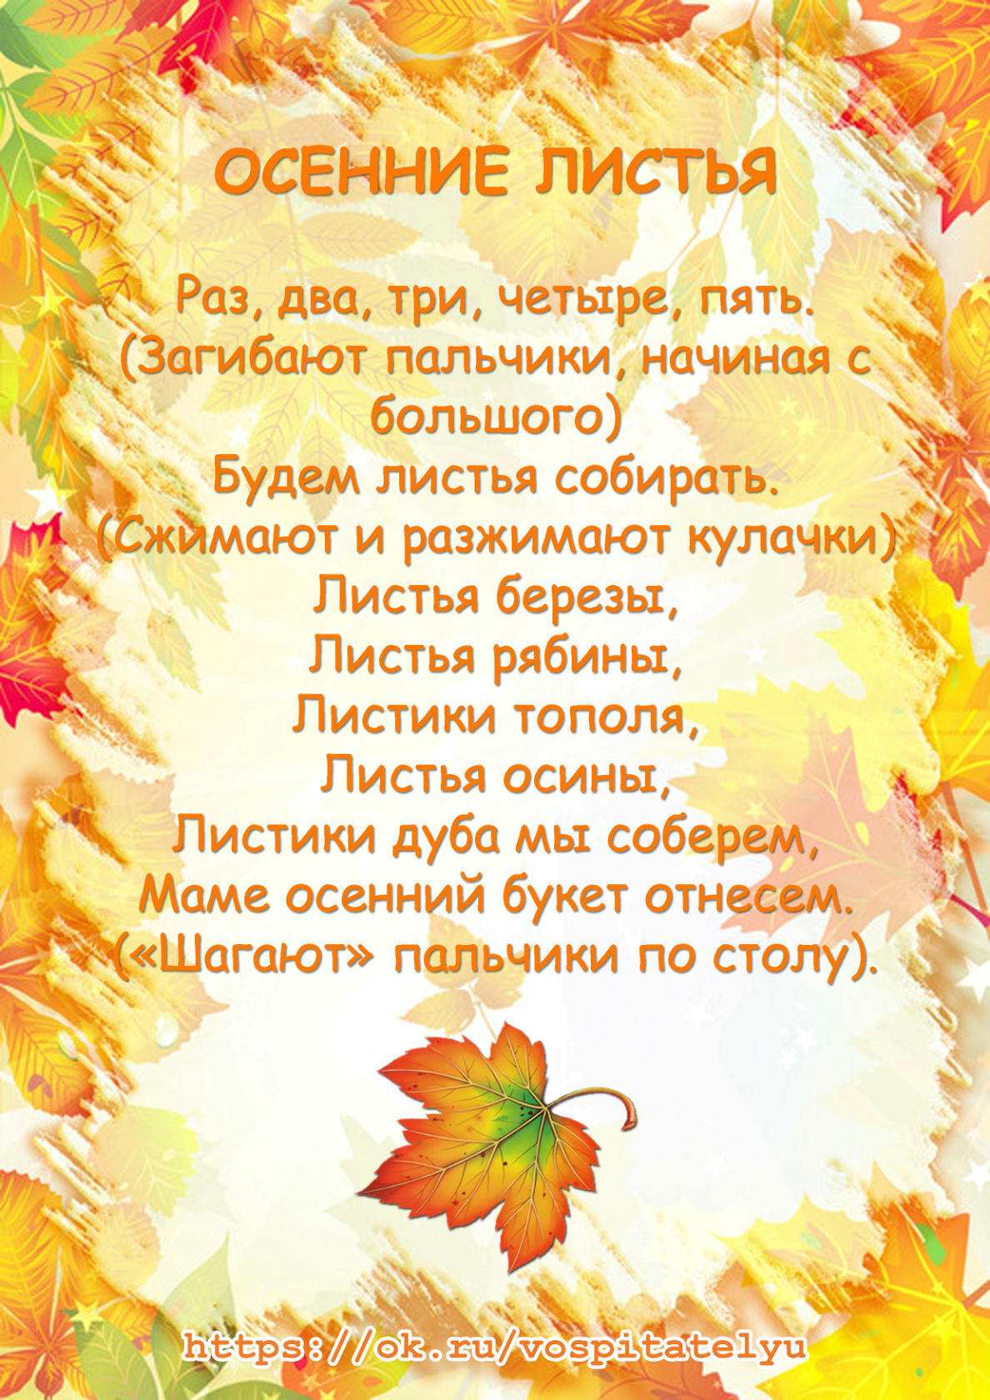](https://ok.ru/dk?cmd=PopLayerPhoto&st.layer.cmd=PopLayerPhotoOuter&st.layer.type=GROUP&st.layer.revNav=off&st.layer.limitedUi=false&st.layer.sphotoIds=858197020829;858197021085;858197021341;858197021597;858197021853;858197022109;858197022365;858197022621;858197022877&st.layer.showNav=on&st.layer.photoAlbumId=50794076962973&st.layer.epm=off&st.layer.photoId=858197021085&st.layer.opl=off&st.layer.navStartPhotoId=858197021085&st.layer.sbd=off&st.cmd=altGroupMain&st.groupId=50395688403101&st.referenceName=metodbv.ru1&st._aid=GroupTopicLayer_openPhotoLayer)

[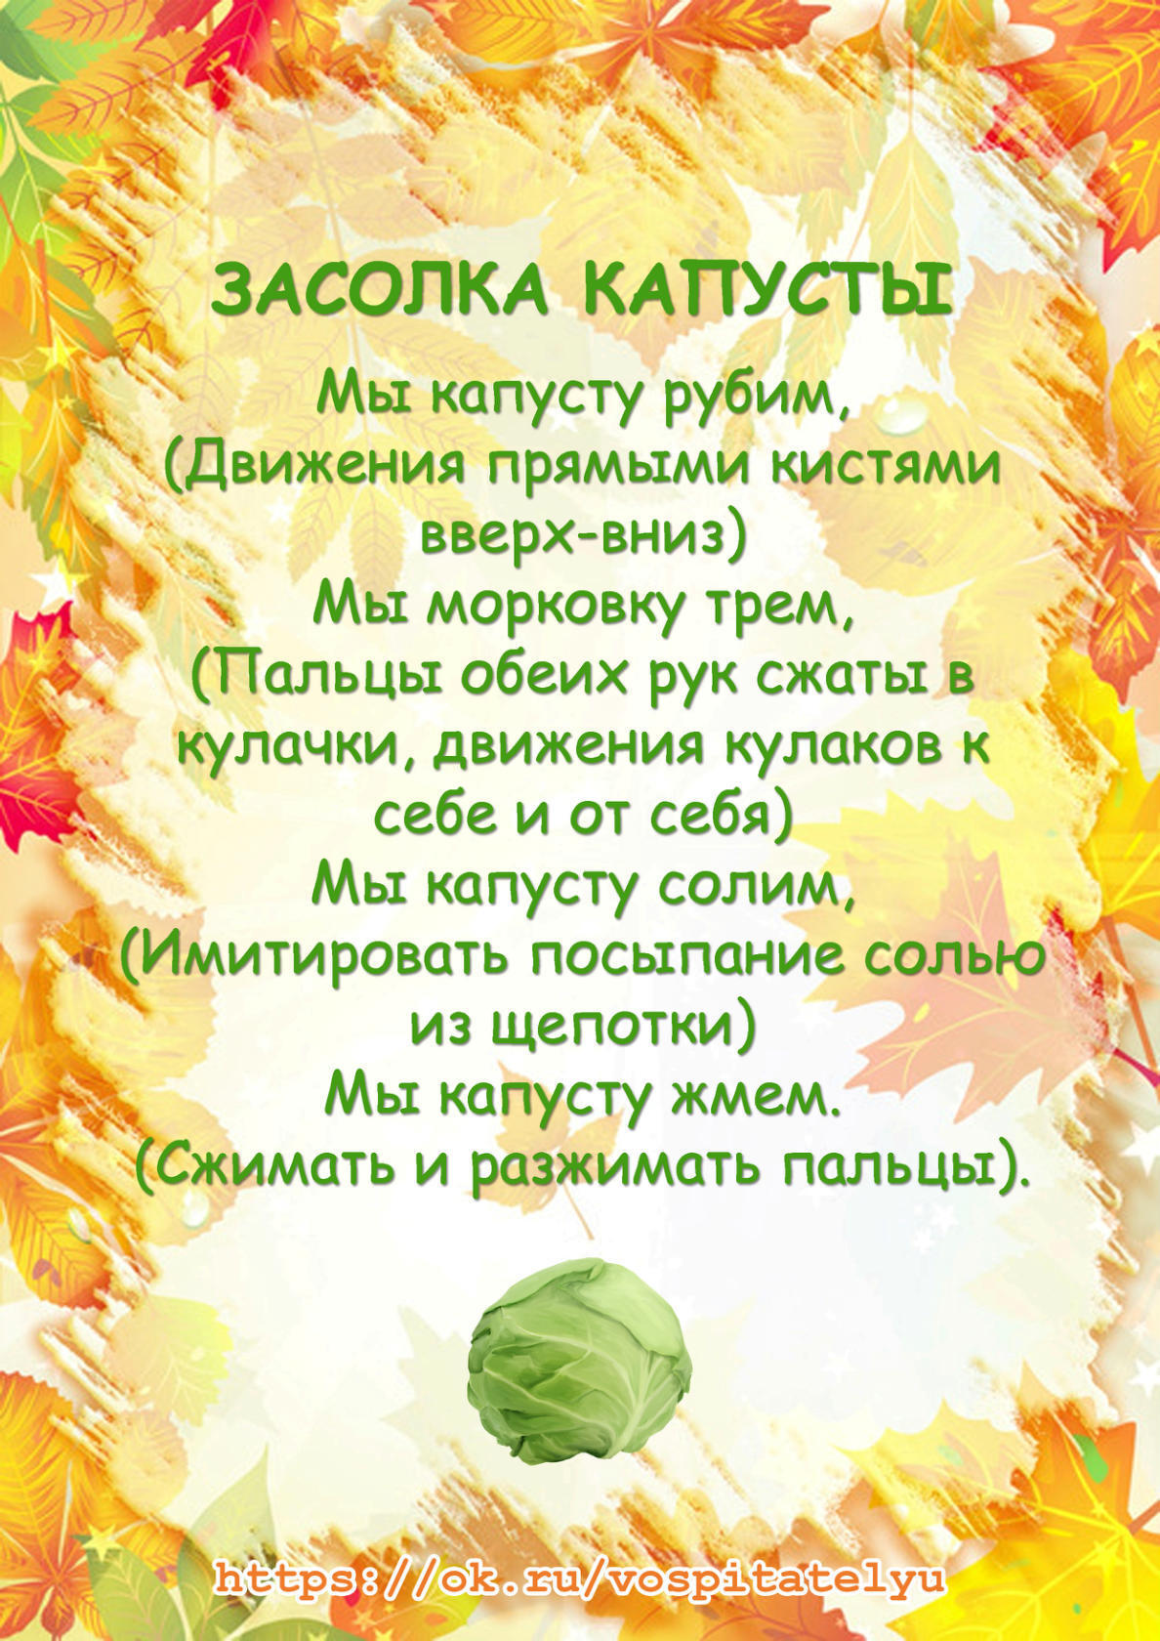](https://ok.ru/dk?cmd=PopLayerPhoto&st.layer.cmd=PopLayerPhotoOuter&st.layer.type=GROUP&st.layer.revNav=off&st.layer.limitedUi=false&st.layer.sphotoIds=858197020829;858197021085;858197021341;858197021597;858197021853;858197022109;858197022365;858197022621;858197022877&st.layer.showNav=on&st.layer.photoAlbumId=50794076962973&st.layer.epm=off&st.layer.photoId=858197021341&st.layer.opl=off&st.layer.navStartPhotoId=858197021341&st.layer.sbd=off&st.cmd=altGroupMain&st.groupId=50395688403101&st.referenceName=metodbv.ru1&st._aid=GroupTopicLayer_openPhotoLayer)

[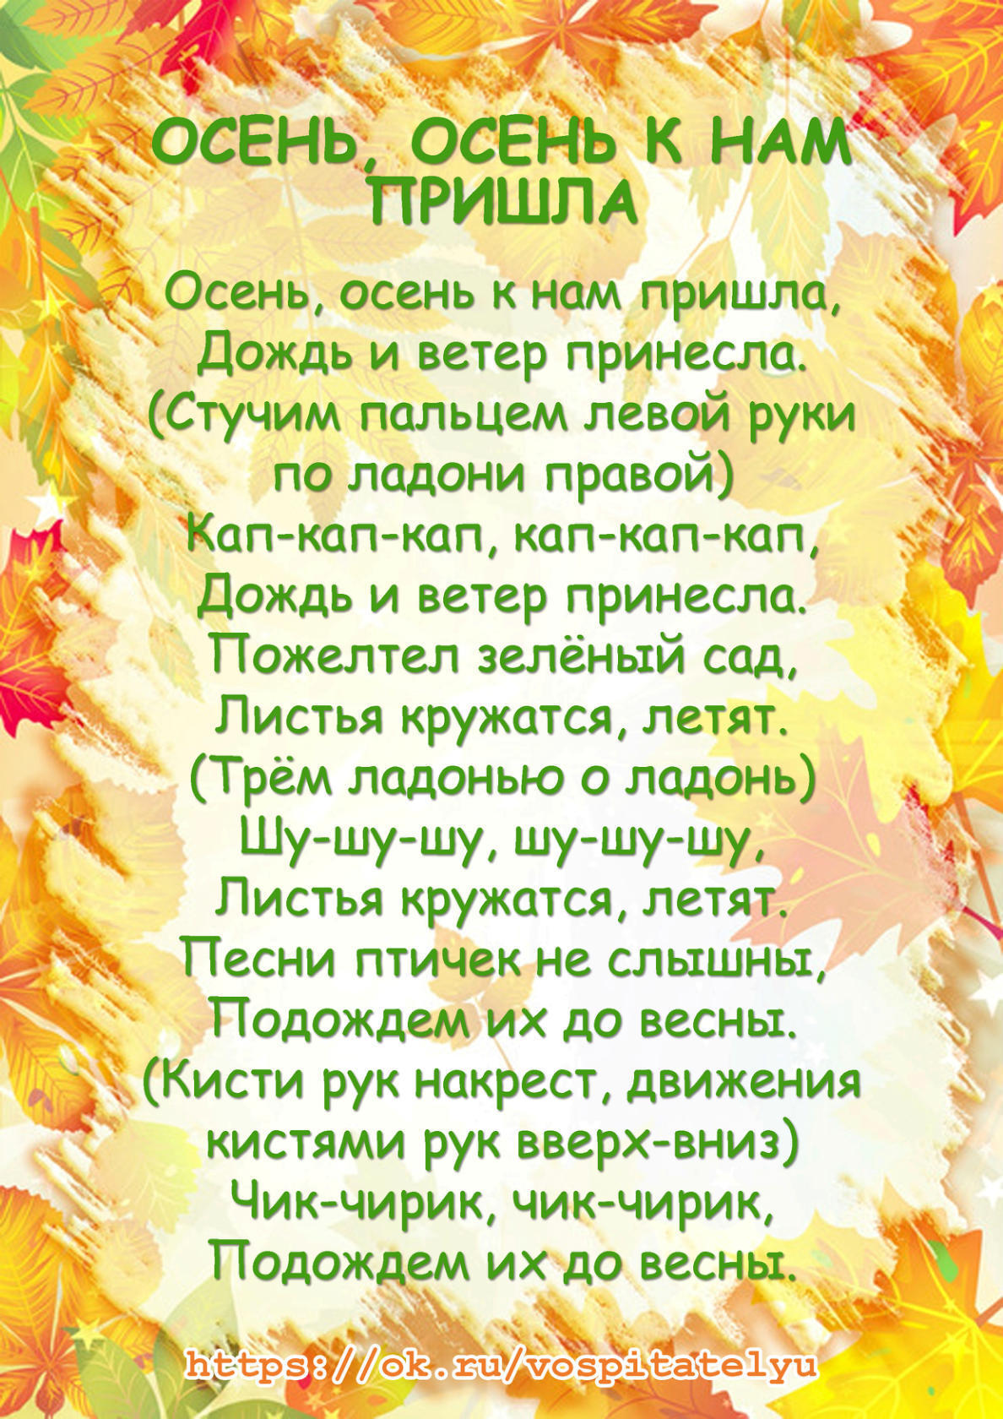](https://ok.ru/dk?cmd=PopLayerPhoto&st.layer.cmd=PopLayerPhotoOuter&st.layer.type=GROUP&st.layer.revNav=off&st.layer.limitedUi=false&st.layer.sphotoIds=858197020829;858197021085;858197021341;858197021597;858197021853;858197022109;858197022365;858197022621;858197022877&st.layer.showNav=on&st.layer.photoAlbumId=50794076962973&st.layer.epm=off&st.layer.photoId=858197021597&st.layer.opl=off&st.layer.navStartPhotoId=858197021597&st.layer.sbd=off&st.cmd=altGroupMain&st.groupId=50395688403101&st.referenceName=metodbv.ru1&st._aid=GroupTopicLayer_openPhotoLayer)

[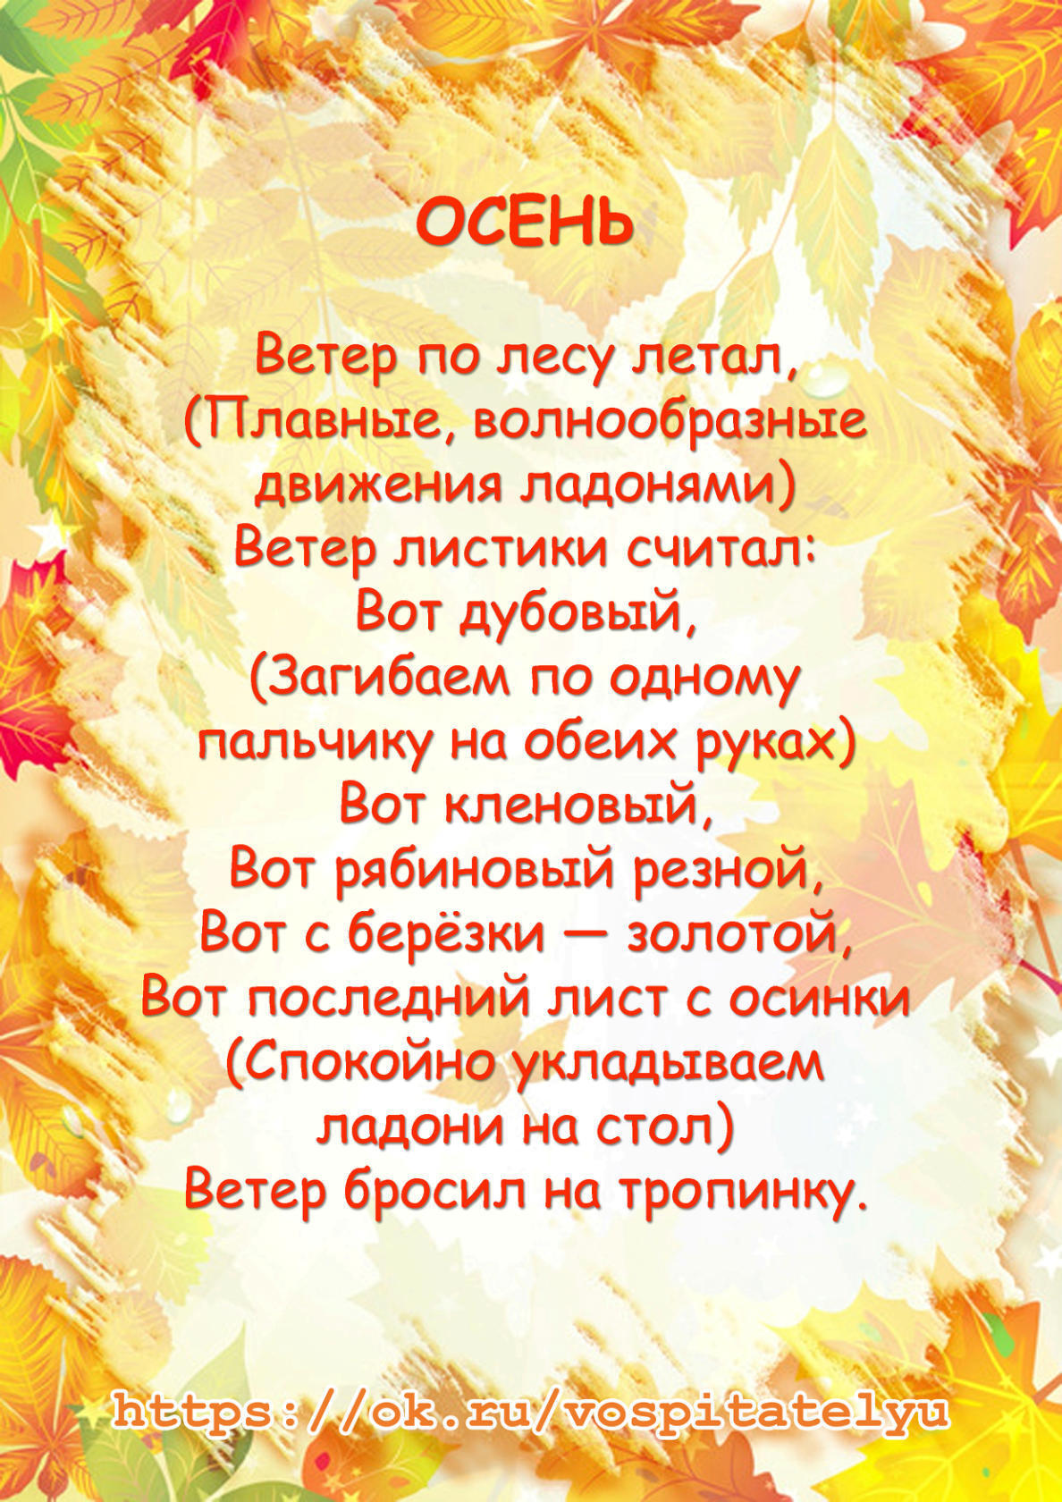](https://ok.ru/dk?cmd=PopLayerPhoto&st.layer.cmd=PopLayerPhotoOuter&st.layer.type=GROUP&st.layer.revNav=off&st.layer.limitedUi=false&st.layer.sphotoIds=858197020829;858197021085;858197021341;858197021597;858197021853;858197022109;858197022365;858197022621;858197022877&st.layer.showNav=on&st.layer.photoAlbumId=50794076962973&st.layer.epm=off&st.layer.photoId=858197021853&st.layer.opl=off&st.layer.navStartPhotoId=858197021853&st.layer.sbd=off&st.cmd=altGroupMain&st.groupId=50395688403101&st.referenceName=metodbv.ru1&st._aid=GroupTopicLayer_openPhotoLayer)

[](https://ok.ru/dk?cmd=PopLayerPhoto&st.layer.cmd=PopLayerPhotoOuter&st.layer.type=GROUP&st.layer.revNav=off&st.layer.limitedUi=false&st.layer.sphotoIds=858197020829;858197021085;858197021341;858197021597;858197021853;858197022109;858197022365;858197022621;858197022877&st.layer.showNav=on&st.layer.photoAlbumId=50794076962973&st.layer.epm=off&st.layer.photoId=858197022109&st.layer.opl=off&st.layer.navStartPhotoId=858197022109&st.layer.sbd=off&st.cmd=altGroupMain&st.groupId=50395688403101&st.referenceName=metodbv.ru1&st._aid=GroupTopicLayer_openPhotoLayer)

[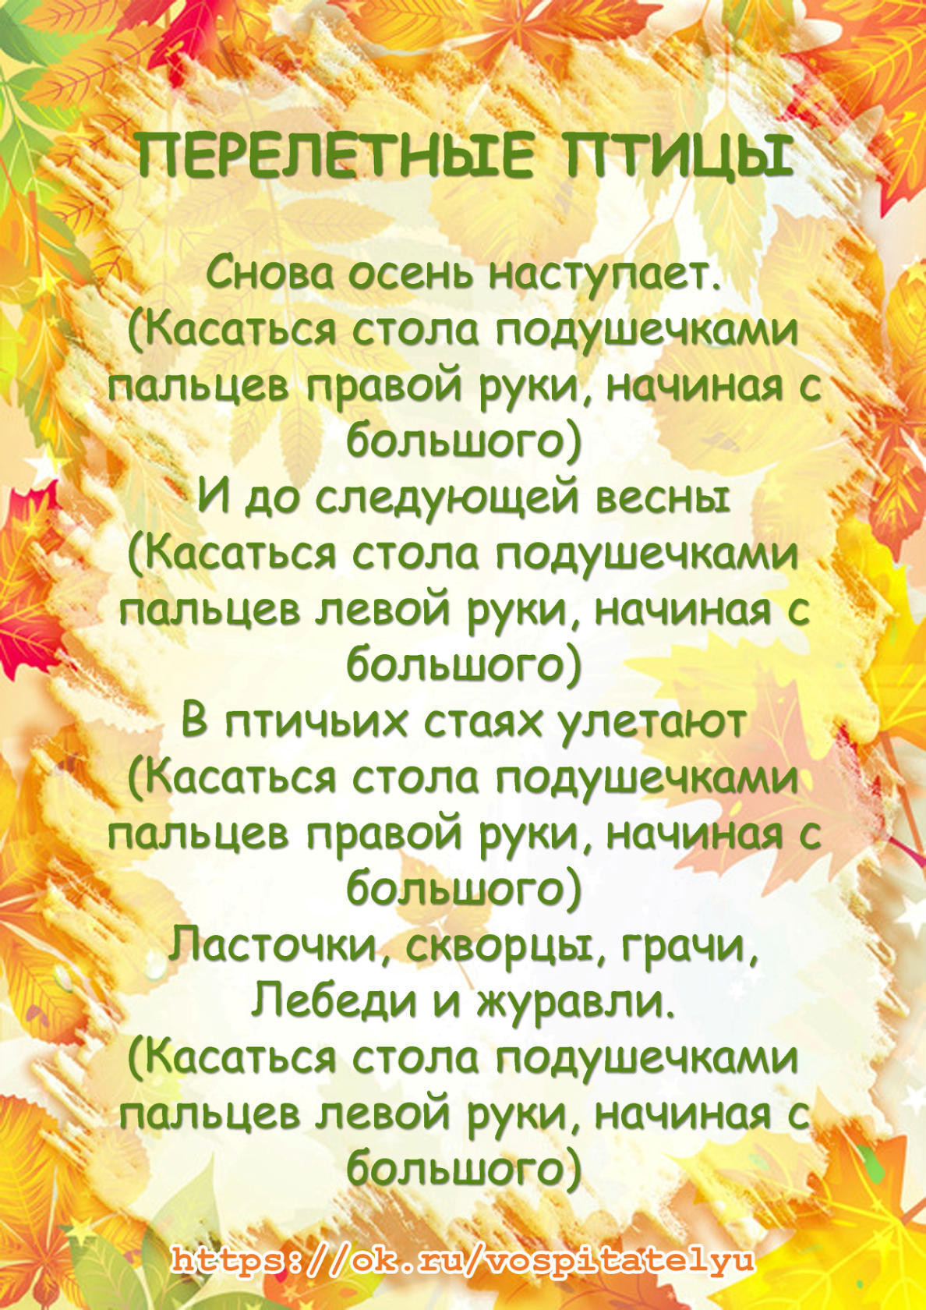](https://ok.ru/dk?cmd=PopLayerPhoto&st.layer.cmd=PopLayerPhotoOuter&st.layer.type=GROUP&st.layer.revNav=off&st.layer.limitedUi=false&st.layer.sphotoIds=858197020829;858197021085;858197021341;858197021597;858197021853;858197022109;858197022365;858197022621;858197022877&st.layer.showNav=on&st.layer.photoAlbumId=50794076962973&st.layer.epm=off&st.layer.photoId=858197022365&st.layer.opl=off&st.layer.navStartPhotoId=858197022365&st.layer.sbd=off&st.cmd=altGroupMain&st.groupId=50395688403101&st.referenceName=metodbv.ru1&st._aid=GroupTopicLayer_openPhotoLayer)

[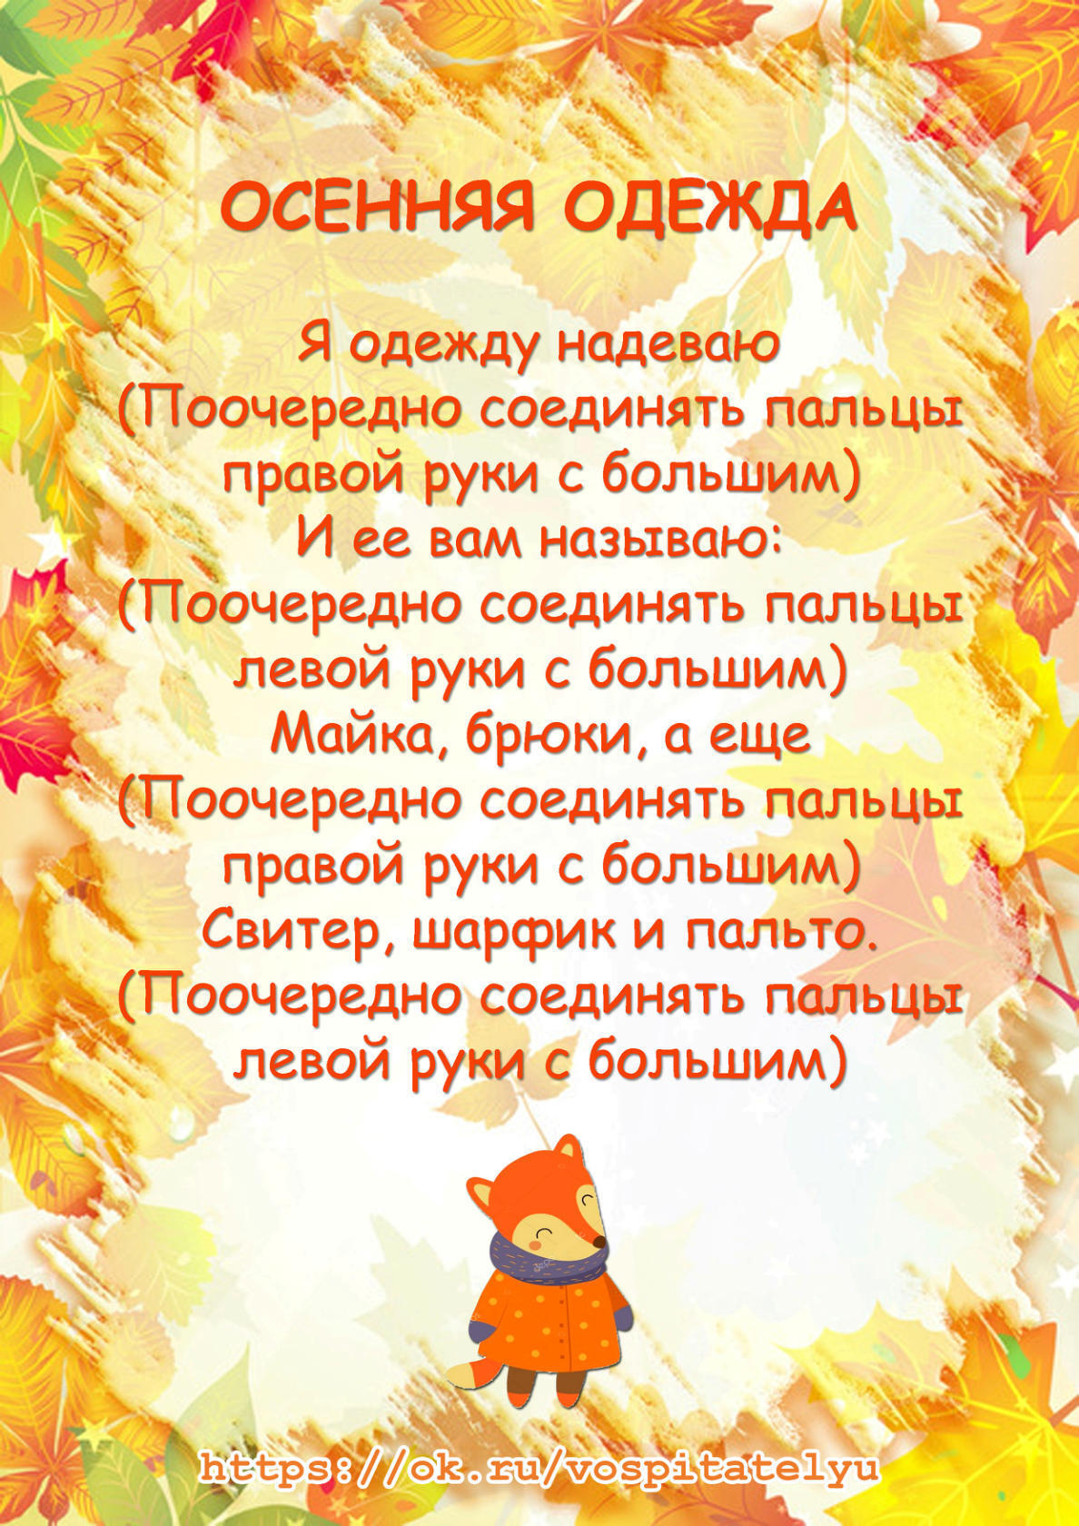](https://ok.ru/dk?cmd=PopLayerPhoto&st.layer.cmd=PopLayerPhotoOuter&st.layer.type=GROUP&st.layer.revNav=off&st.layer.limitedUi=false&st.layer.sphotoIds=858197020829;858197021085;858197021341;858197021597;858197021853;858197022109;858197022365;858197022621;858197022877&st.layer.showNav=on&st.layer.photoAlbumId=50794076962973&st.layer.epm=off&st.layer.photoId=858197022621&st.layer.opl=off&st.layer.navStartPhotoId=858197022621&st.layer.sbd=off&st.cmd=altGroupMain&st.groupId=50395688403101&st.referenceName=metodbv.ru1&st._aid=GroupTopicLayer_openPhotoLayer)

[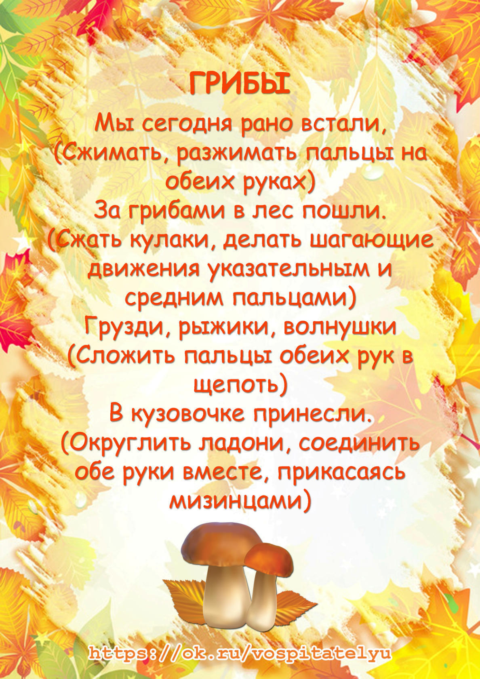](https://ok.ru/dk?cmd=PopLayerPhoto&st.layer.cmd=PopLayerPhotoOuter&st.layer.type=GROUP&st.layer.revNav=off&st.layer.limitedUi=false&st.layer.sphotoIds=858197020829;858197021085;858197021341;858197021597;858197021853;858197022109;858197022365;858197022621;858197022877&st.layer.showNav=on&st.layer.photoAlbumId=50794076962973&st.layer.epm=off&st.layer.photoId=858197022877&st.layer.opl=off&st.layer.navStartPhotoId=858197022877&st.layer.sbd=off&st.cmd=altGroupMain&st.groupId=50395688403101&st.referenceName=metodbv.ru1&st._aid=GroupTopicLayer_openPhotoLayer)